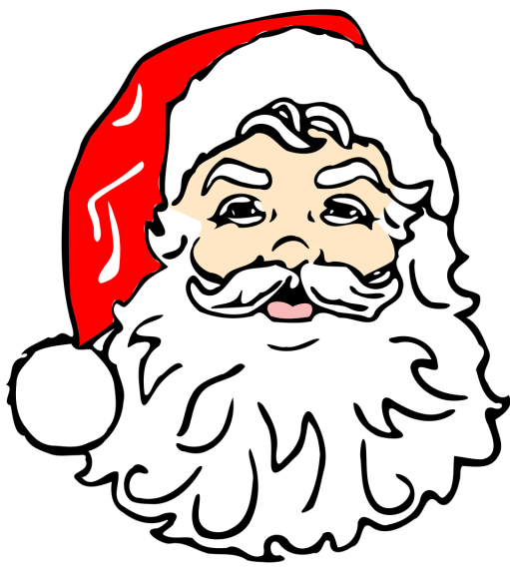
CHRISTMAS ON BROADWAY

SANTA CLAUS IS COMING TO FOX’S PIZZA

SATURDAY, DECEMBER 10TH, 2016
SANTA ARRIVES AT 2:30PM and
heads back to the North Pole at 4:30PM

                - Photos with Santa Claus
                - Face Painting
                - Horse drawn carriage rides at 2:30pm
                - Christmas loot bags for every child
                - Kids crafts to make and take

Tree Lighting Ceremony
at the island on Broadway & Valley at 5pm.

This FREE EVENT is sponsored by the
STOWE COMMUNITY LIFE COMMITTEE!

